CMPS 350 Web Development Course Project Phase 2
Student Management Application

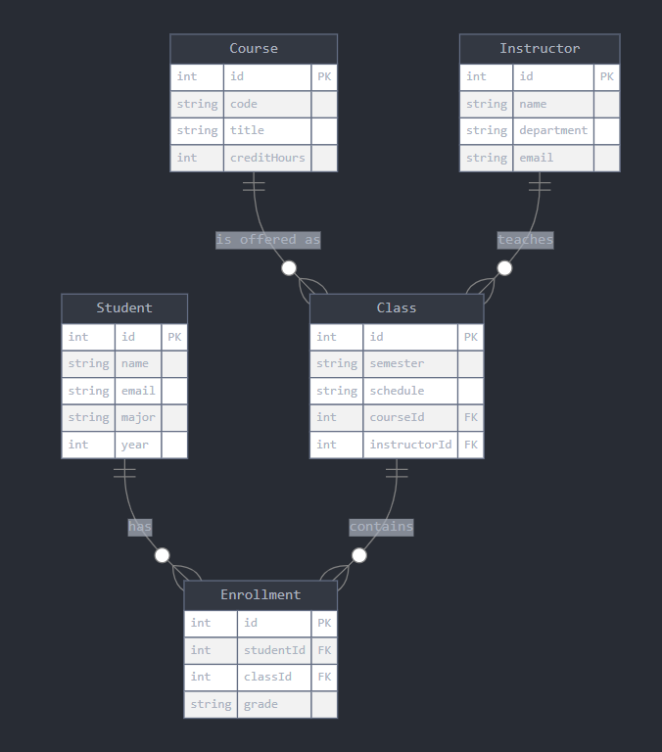

# Course Management System - Conceptual Data Model

## Entities and Relationships

### 1. User
- Base attributes for all user types:
- id (Primary Key)
- username (Unique)
- password (Encrypted)
- name
- type (student/instructor/admin)

#### Student (extends User)
- Attributes:
- completed_courses: [Course References]
- Relationships:
- Can enroll in many Classes
- Can complete many Courses
- Can have pending enrollment requests

#### Instructor (extends User)
- Attributes:
- expertise: [Categories]
- interested_courses: [Course References]
- Relationships:
- Can teach many Courses
- Can manage multiple Classes

#### Admin (extends User)
- Relationships:
- Can manage all entities
- Validates class creation
- Approves course proposals

### 2. Course
- Attributes:
- code (Primary Key)
- name
- category
- prerequisites: [Course References]
- status (active/rejected)
- Relationships:
- Has many Classes
- Has one Instructor
- Has many enrolled Students
- Can be prerequisite for other Courses

### 3. Class
- Attributes:
- course_id (Foreign Key)
- instructor_id (Foreign Key)
- capacity
- validated (boolean)
- schedule:
- day
- time
- Relationships:
- Belongs to one Course
- Has one Instructor
- Has many enrolled Students
- Has many pending Students

## Data Validation Rules

1. User Management:
- Usernames must be unique
- Passwords must be securely stored
- User types must be one of: student, instructor, or admin

2. Course Management:
- Course codes must be unique
- Prerequisites must reference existing courses
- Course status must be either active or rejected
- Category must be from predefined list

3. Class Management:
- Cannot exceed capacity
- Must have valid instructor assignment
- Must be validated before accepting students
- Schedule must not conflict with instructor's other classes

## Access Control

1. Students can:
- View available courses
- Request enrollment in classes
- View their completed courses
- View their current enrollments

2. Instructors can:
- Propose new courses
- Manage their assigned classes
- View student enrollments
- Update course materials

3. Admins can:
- Manage all users
- Validate classes
- Approve/reject courses
- Monitor system activity

## Data Relationships

```
User (Abstract)
├── Student
│ ├── enrolled_in → Classes (Many-to-Many)
│ └── completed → Courses (Many-to-Many)
├── Instructor
│ ├── teaches → Courses (One-to-Many)
│ └── manages → Classes (One-to-Many)
└── Admin
└── manages → All Entities

Course
├── has → Classes (One-to-Many)
├── taught_by → Instructor (Many-to-One)
├── enrolled_students → Students (Many-to-Many)
└── prerequisites → Courses (Many-to-Many)

Class
├── belongs_to → Course (Many-to-One)
├── taught_by → Instructor (Many-to-One)
├── enrolled_students → Students (Many-to-Many)
└── pending_students → Students (Many-to-Many)

